Scope of Work

## Developer Name

Daniel Cook

## Date

06/25/2020

## Gitrepo or source files

* Back End: <https://github.com/dmc3152/iot-be>
* User Interface: <https://github.com/dmc3152/iot-ui>

## Title

IoT Controller

## Design Concept

## Architecture and Technical

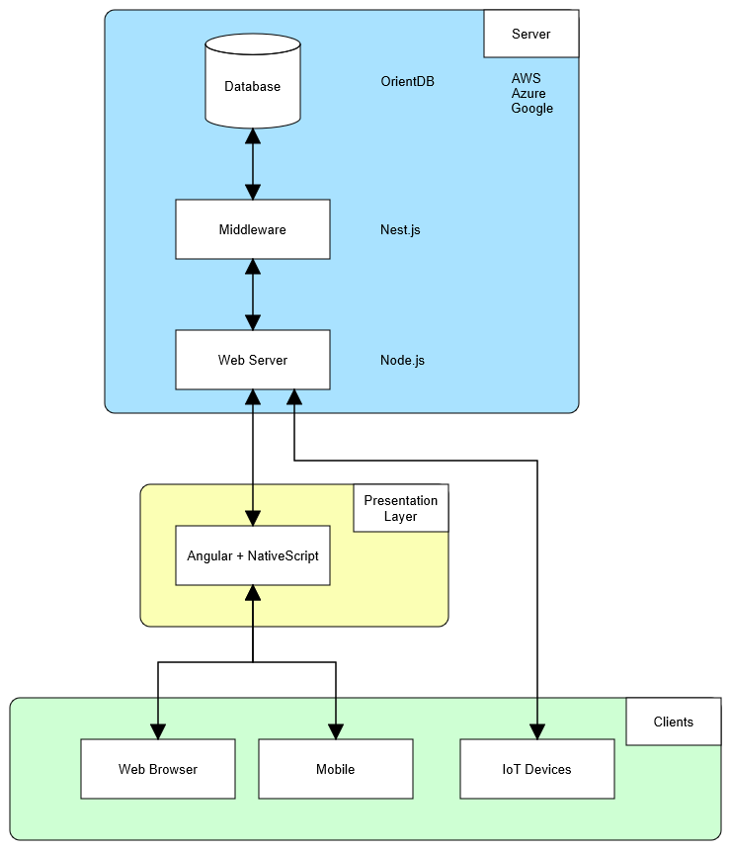

## Some Requirements, Foundations and Features

* Users can have individual accounts
* Users can enter custom data schemas for their devices
* Users can view data visualizations

## Planning/Stages

## Deliverables/Milestones

## Status

Development